Installation of MySql

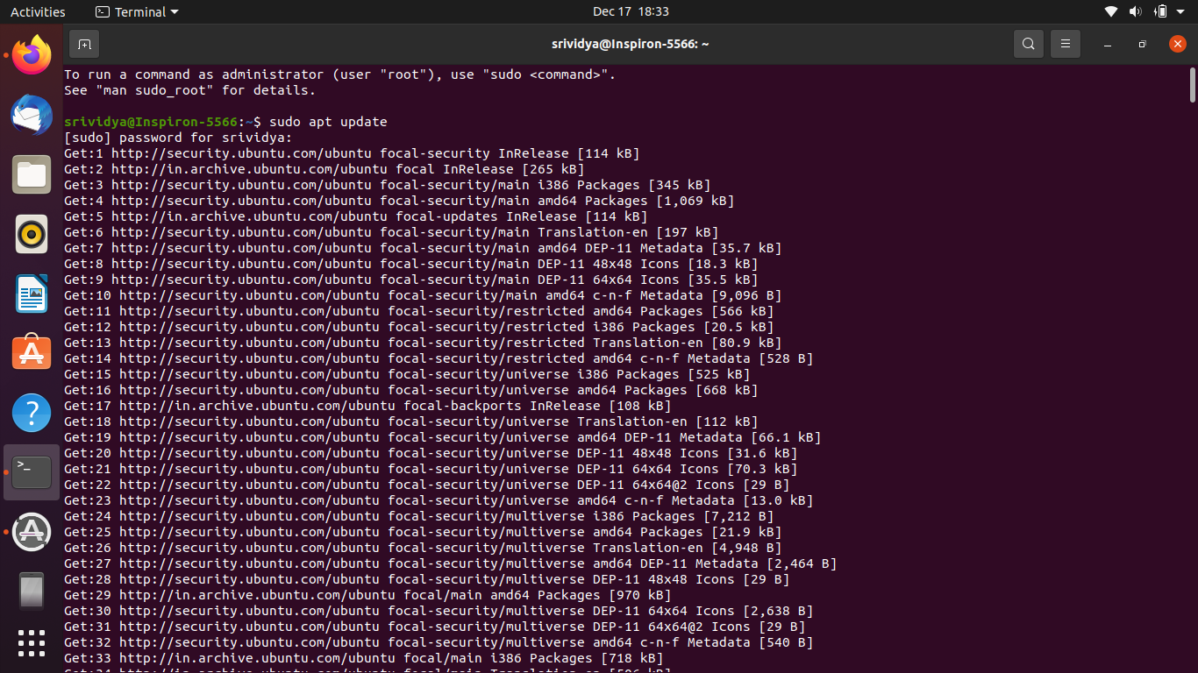

$sudo apt update

$sudo apt upgrade

# 

# $sudo apt-get install mysql-server

* It will install the mysql on ubuntu

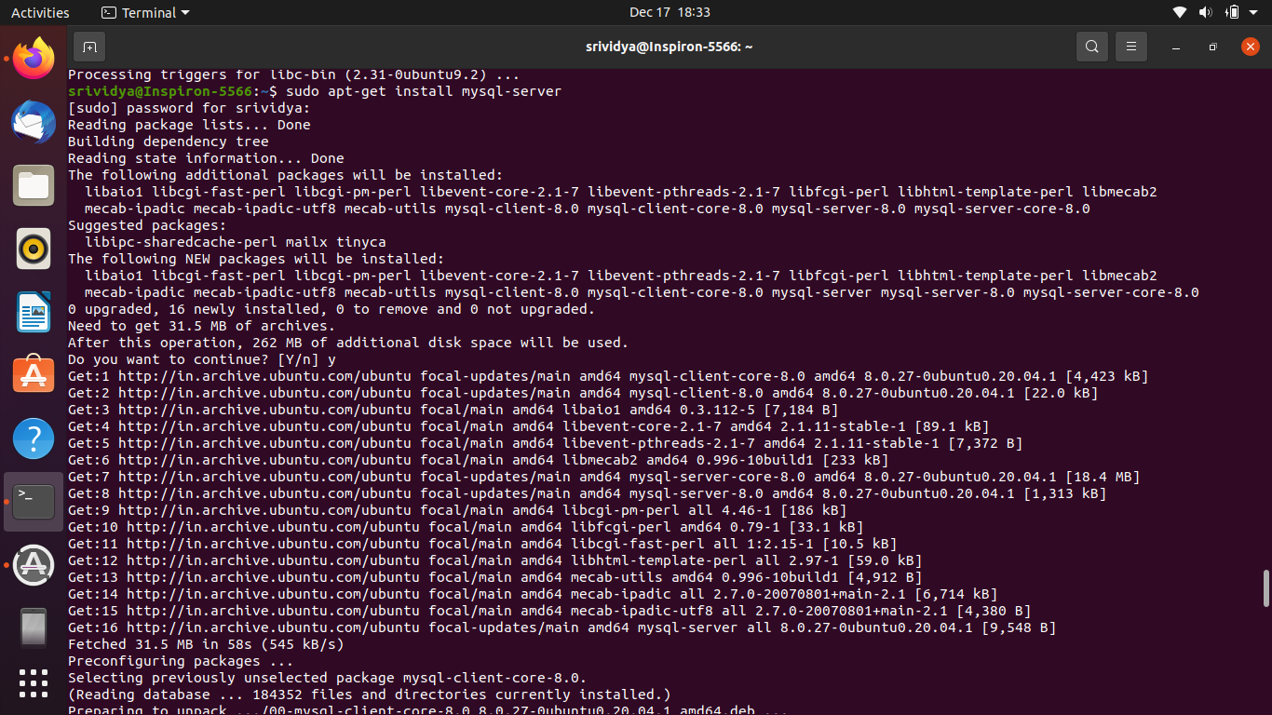

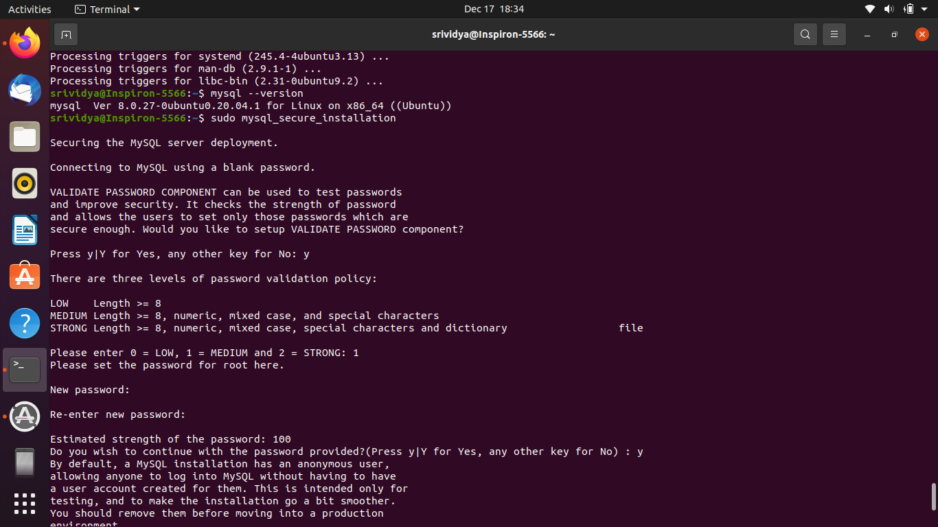

$sudo mysql_secure_installation

* You can set your password for mysql
* By choosing given options like strong or weak

### 

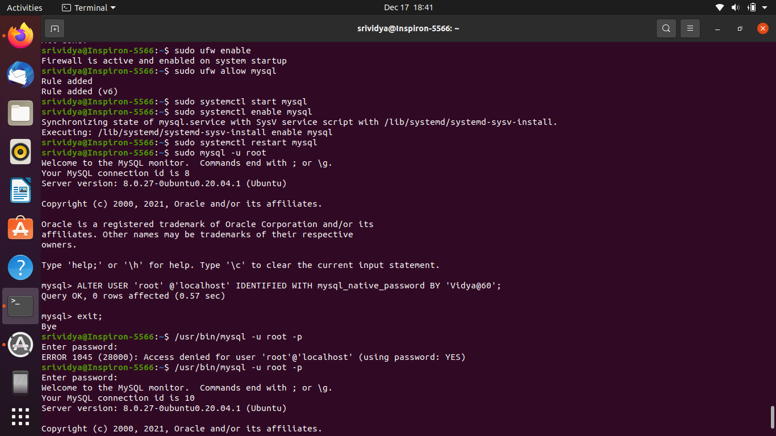

Follow the below steps:-

$sudo ufw enable

$sudo ufw allow mysql

$sudo systemctl start mysql

$sudo systemctl restart mysql

$sudo mysql -u root

mysql> ALTER USER ‘root’ @’localhost’ IDENTIFIED WITH mysql_native_password BY ‘your password’;

mysql> exit;

/usr/bin/mysql -u root -p

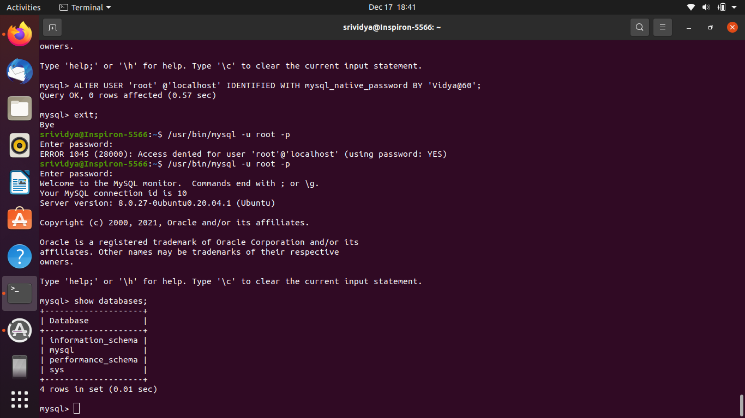

### After the above steps u can proceed with mysql:

mysql>show databases;

mysql>CREATE DATABASE demodb;

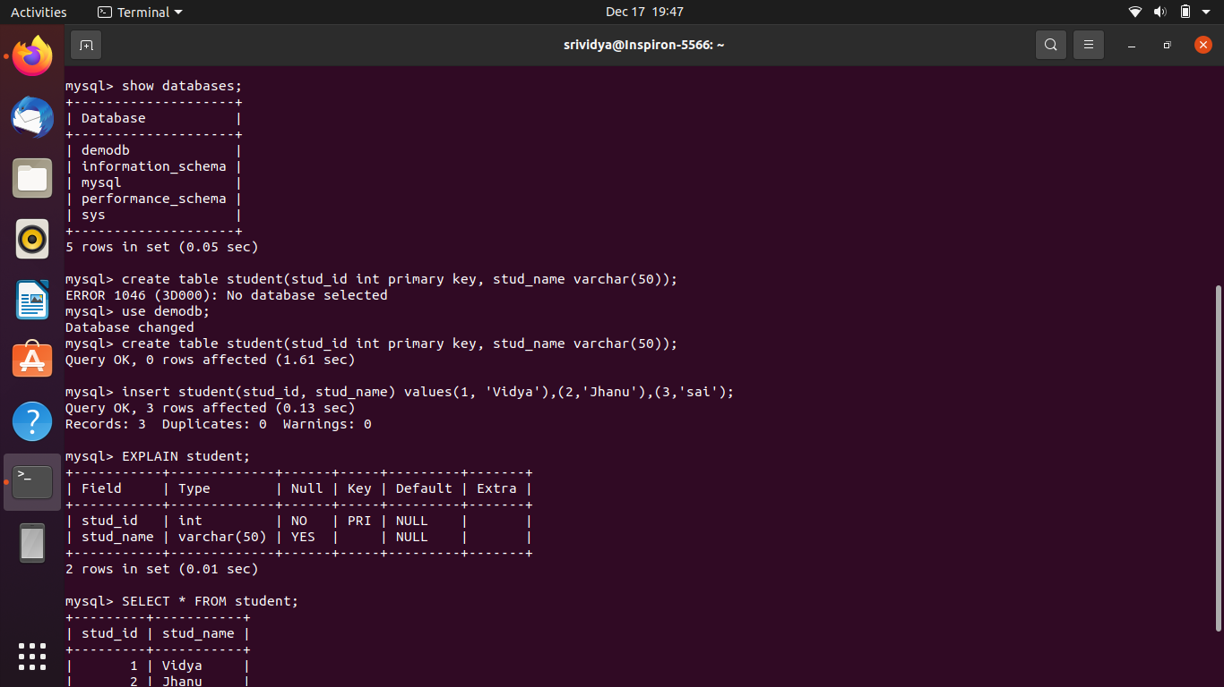

mysql>CREATE TABLE student(stud_id INT PRIMARY KEY, stud_name VARCHAR(50));

mysql> EXPLAIN student;

mysql>INSERT INTO student(stud_id , stud_name) VALUES(1,’Vidya’),(2,’Jhanu’),(3,’Pavi’);

### 

## CRUD Operations On Terminal

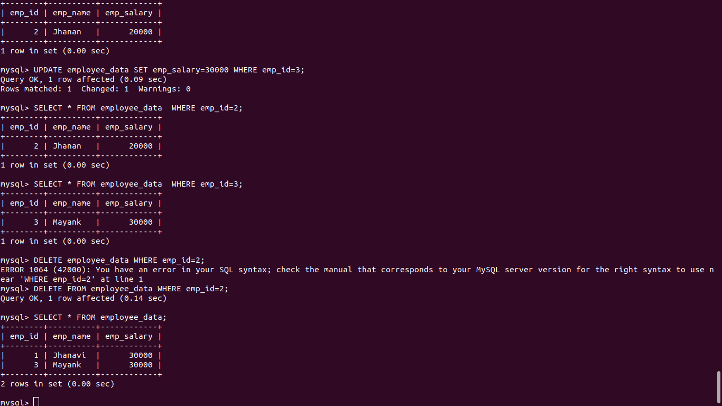

mysql> UPDATE table_name SET column_name WHERE column_name=value

* We can update the data using UPDATE query

mysql> DELETE table_name WHERE column_name=value

* You can delta data using DELETE query

mysql> SELECT *FROM table_name

* Reading data using above query

## Joins:-

* Inner join
* Left join
* Right join
* Outer join

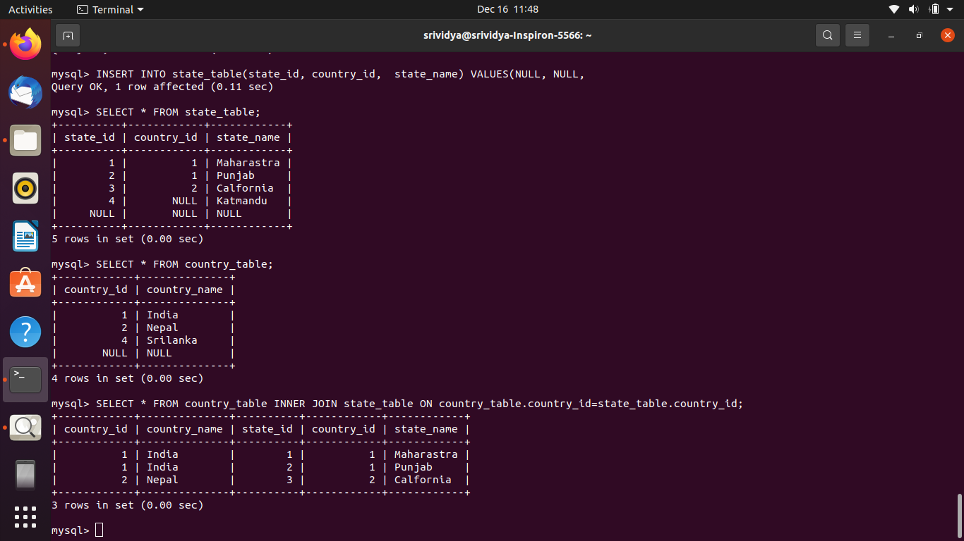

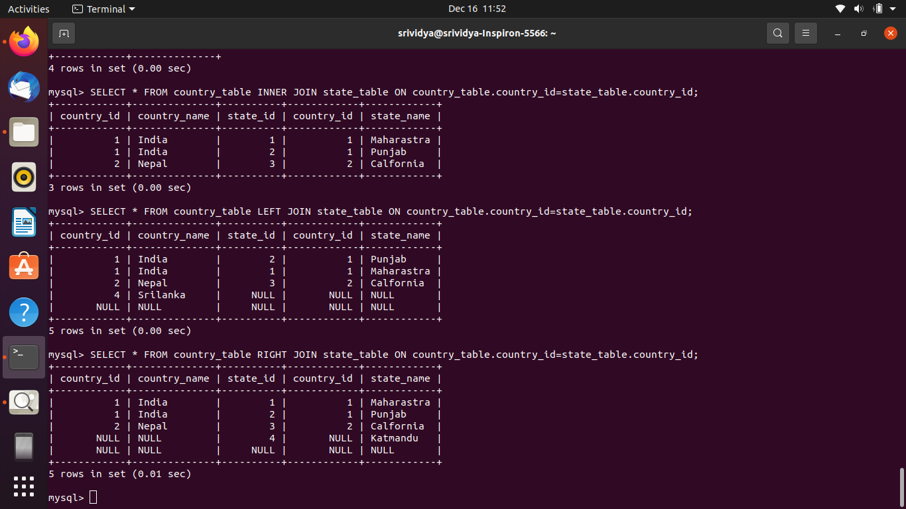

mysql> SELECT * FROM country_table INNER JOIN state_table ON country_table.country_id=state_table.country_id;

mysql> SELECT * FROM country_table LEFT JOIN state_table ON country_table.country_id=state_table.country_id;

mysql> SELECT * FROM country_table RIGHT JOIN state_table ON country_table.country_id=state_table.country_id;

mysql> SELECT * FROM country_table FULL OUTER JOIN state_table ON country_table.country_id=state_table.country_id;

## Primary Key and ForeignKey

CREATE TABLE students_table2(id INT PRIMARY KEY, name VARCHAR(50));

INSERT INTO students_table2(id, name) VALUES(1,’Vidya’),(2,’Jhanu’),(3,’Pavi’);

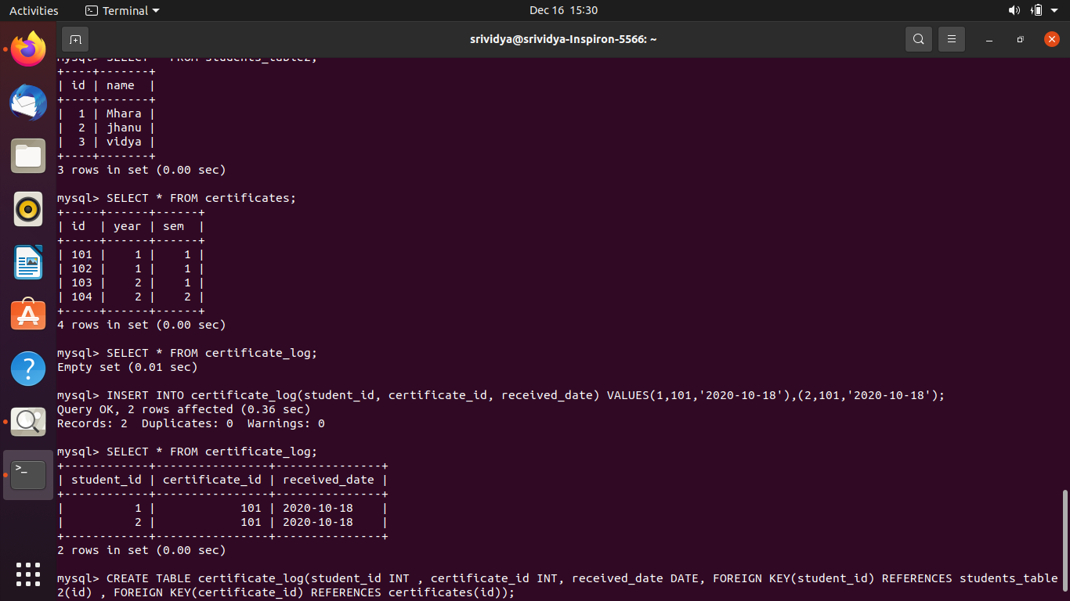

CREATE TABLE certificate_log(student_id INT, certificate_id INT, FOREGIN KEY(student_id) REFERENCES students_table2(id));

INSERT INTO certificate_log(student_id, certificate_id) VALUES(1,101),(2,102),(3,104);

## Functions:-

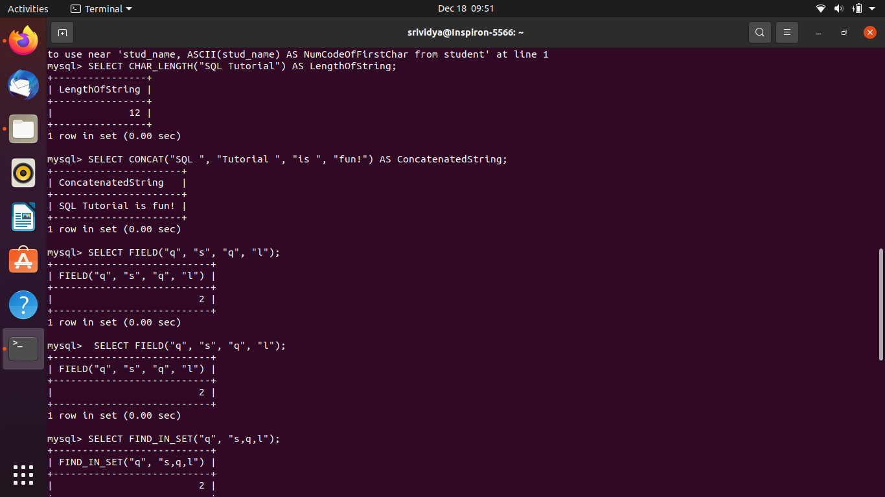

mysql> SELECT CHAR_LENGTH("SQL Tutorial") AS LengthOfString;

mysql> SELECT CONCAT("SQL ", "Tutorial ", "is ", "fun!") AS ConcatenatedString;

mysql> SELECT FIELD("q", "s", "q", "l");

mysql> SELECT FIND_IN_SET("q", "s,q,l");

mysql> SELECT FORMAT(250500.5634, 2);

mysql> SELECT INSERT("W3Schools.com", 1, 9, "Example");

mysql> SELECT INSTR("W3Schools.com", "3") AS MatchPosition;

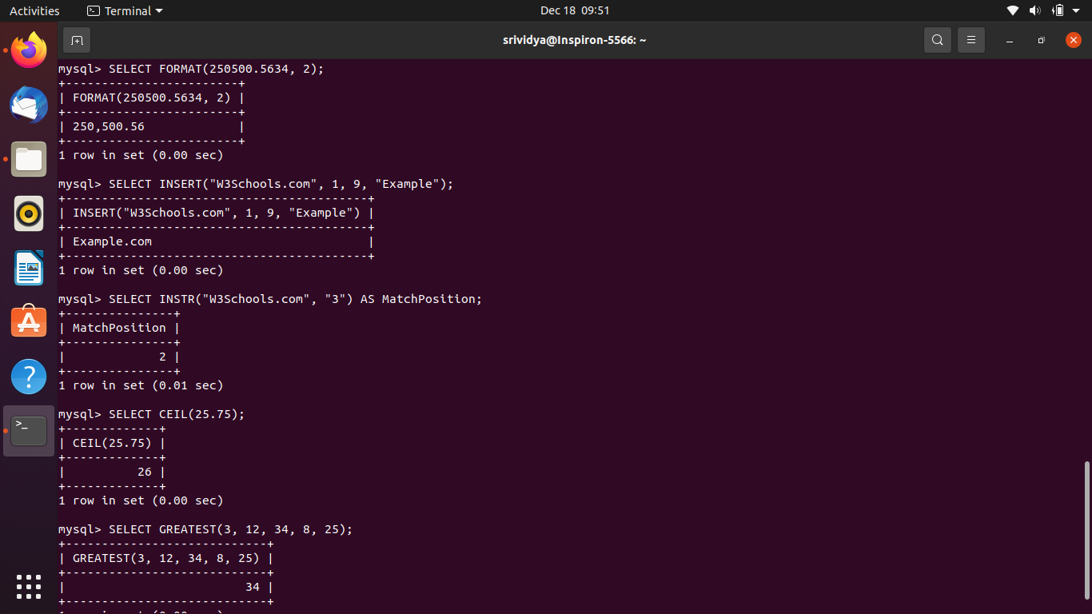

mysql> SELECT CEIL(25.75);

mysql> SELECT GREATEST(3, 12, 34, 8, 25);

mysql> SELECT POW(4, 2);

mysql> SELECT ROUND(135.375, 2);

mysql> SELECT TRUNCATE(135.375, 2);

mysql> SELECT SIN(2);

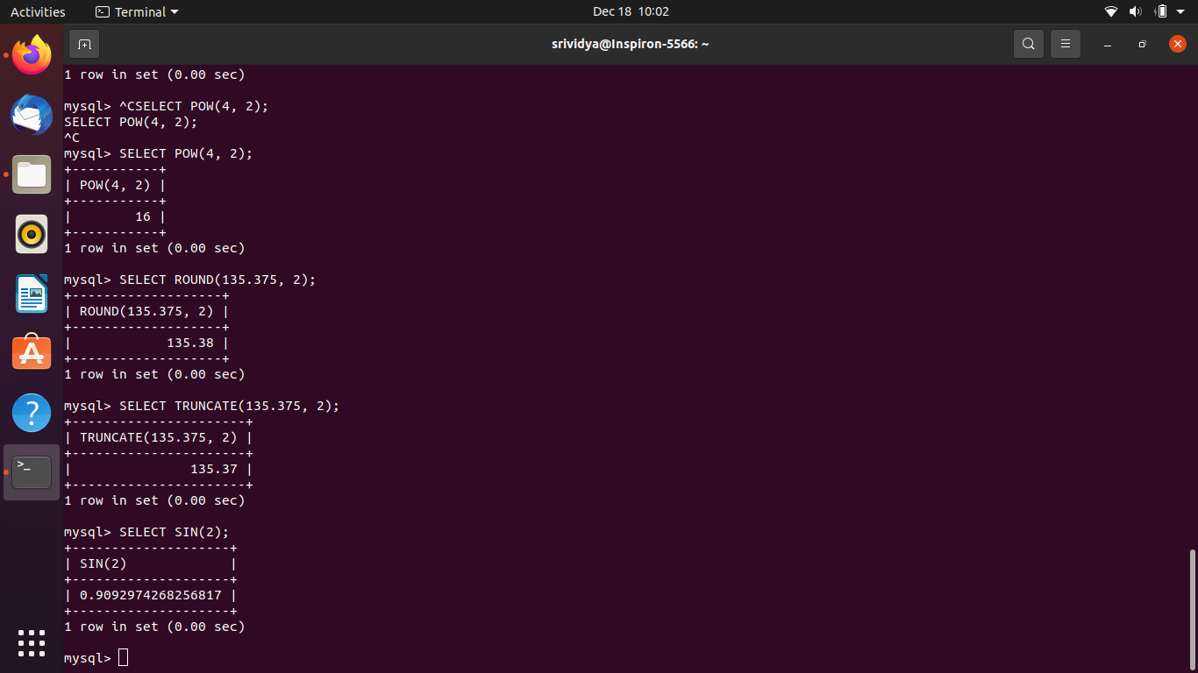

## Index:-

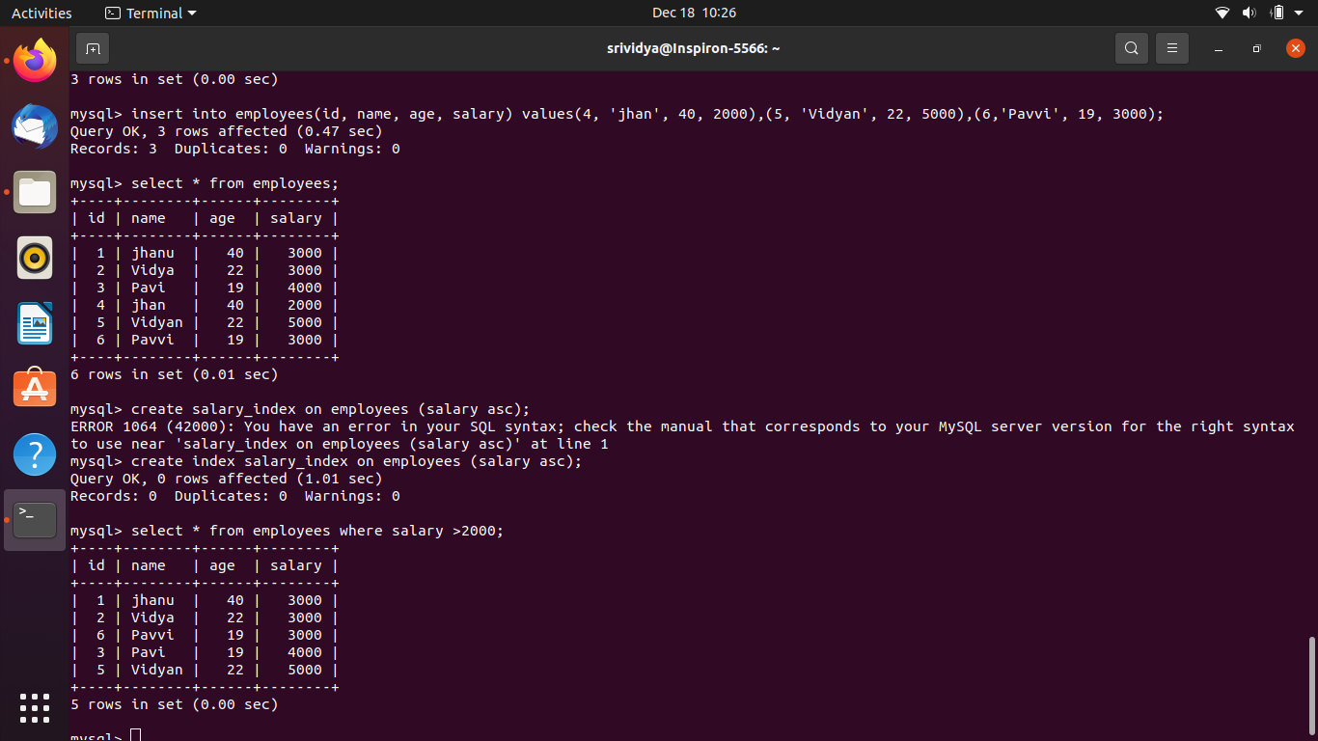

mysql> select * from employees;

mysql> create index salary_index on employees (salary asc);

mysql> select * from employees where salary >2000;

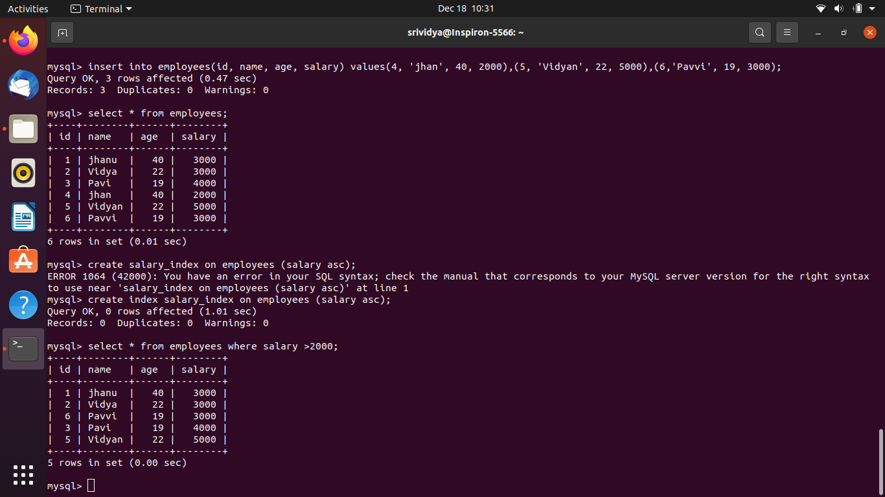

## View:-

mysql> create view my_view as select id,name,age from employees;

mysql> select * from my_view;

